Q1: 1. Write a JavaScript function to get the values of First and Last name of the following form.

Code:

<!DOCTYPE html>

<html>

<head>

 <meta charset=utf-8 />

 <title>Return first and last name from a form </title>

 </head>

<body>

 <form id="form1" onsubmit="getFormvalue()">

 First name:

 <input type="text" name="fname" value="David"><br>

 Last name:

 <input type="text" name="lname" value="Beckham"><br>

 <input type="submit" value="Submit">

 </form>

 <script>

    function getFormvalue()

     {

         var name = document.getElementsByName('fname')[0].value;

         var lname = document.getElementsByName('lname')[0].value;

         alert(`First Name: ${name} and Last Name: ${lname}`);

     }

 </script>

</body>

</html>

Output:

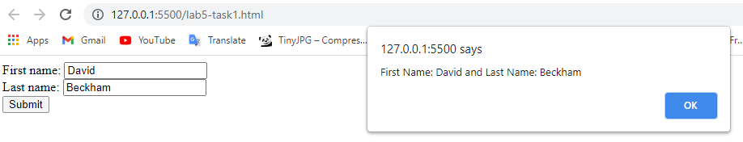

2. Write a JavaScript program to set the background color of a paragraph.

Code:

<!DOCTYPE html>

<html>

<head>

 <meta charset=utf-8 />

 <title>JS Bin</title>

</head>

<body>

 <input type="button" value="Click to set paragraph background color" onclick="set_background()">

 <p>w3resource JavaScript Exercises</p>

 <p>w3resource PHP Exercises</p>

 <script>

    function set_background()

     {

         document.getElementsByTagName('p')[0].style.background = "rgb(255,0,0)";

         document.getElementsByTagName('p')[1].style.background = "rgb(256,0,0)";

     }

 </script>

</body>

</html>

Output:

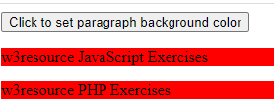

3. Here is a sample html file with a submit button. Write a JavaScript function to get the value of the href, hreflang, rel, target, and type attributes of the specified link.

Code:

<!DOCTYPE html>

<html>

<head>

 <meta charset=utf-8 />

</head>

<body>

 <p><a id="w3r" type="text/html" hreflang="en-us" rel="nofollow"

    target="_self" href="http://www.w3resource.com/">w3resource</a></p>

 <button onclick="getAttributes()">Click here to get attribute value</button>

 <script>

     function getAttributes()

     {

         var href = document.getElementById("w3r").href;

         var hreflang = document.getElementById("w3r").hreflang;

         var rel =      document.getElementById("w3r").rel;

         var target =   document.getElementById("w3r").target;

         var type =     document.getElementById("w3r").type;

         alert(`HREF=${href}, hreflang=${hreflang}, rel=${rel}, target=${target}, type=${type}`)

     }

 </script>

</body>

</html>

Output:

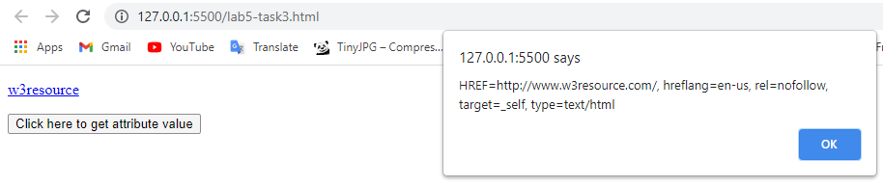

4. Here is a sample html file with a submit button. Now modify the style of the paragraph text (such as fontSize, fontFamily, color, etc. ) through javascript code.

Code:

<!DOCTYPE html>

<html><br>

<head>

 <meta charset=utf-8 />

 <title>JS DOM paragraph style</title>

</head>

<body>

 <p id='text'>JavaScript Exercises - w3resource</p>

 <div>

 <button id="jsstyle" onclick="js_style()">Style</button>

 </div>

 <script>

     function js_style()

     {

        var paragraph = document.getElementById('text')[0];

        paragraph.style.background = 'lightgreen';

        paragraph.innerText.style.fontFamily = 'Arial, Helvetica, sans-serif;'

        paragraph.style.fontSize= '40px';

        paragraph.style.color= 'blue';

     }

 </script>

</body>

</html>

5. Write a JavaScript function to add rows to a table.

Code:

<!DOCTYPE html>

<html>

<head><br>

 <meta charset=utf-8 />

 <title>Insert row in a table - w3resource</title>

</head>

<body>

 <table id="sampleTable" border="1">

 <tr>

 <td>Row1 cell1</td>

 <td>Row1 cell2</td>

 </tr>

 <tr>

 <td>Row2 cell1</td>

 <td>Row2 cell2</td>

 </tr>

 </table><br>

 <input type="button" onclick="insert_Row()" value="Insert row">

 <script>

     function insert_Row()

        {

        var x=document.getElementById('sampleTable').insertRow(0);

        var cell1 = x.insertCell(0);

        var cell2 = x.insertCell(1);

        cell1.innerHTML="New Cell1";

        cell2.innerHTML="New Cell2";

        }

 </script>

</body>

</html>

Output:

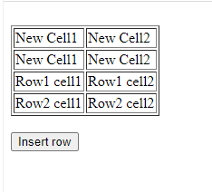

6. Write the code necessary to do the following:

1. Select the section with an id of container without using querySelector.

Sol: let elem = document.getElementById("container");

Output

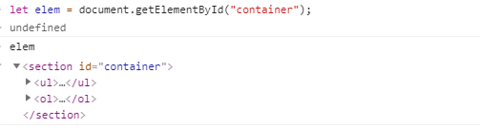

1. Select the section with an id of container using querySelector.

Solution: let elem1 = document.querySelector("#container");

Output:

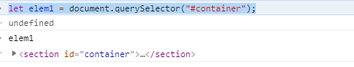

1. Select all of the list items with a class of "second".

Solution: let elem2 = document.querySelectorAll(".second");

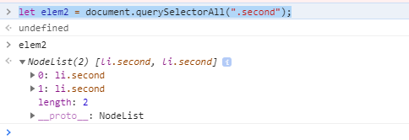

1. Select a list item with a class of third, but only the list item inside of the ol tag.

Solution: let elem4 = document.querySelectorAll('ol > .third ');

Output:

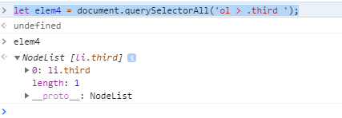

1. Give the section with an id of container the text "Hello!".

Solution: let elem6 = document.querySelector('#container');

elem6.innerText = "Hello Safdar"

Output:

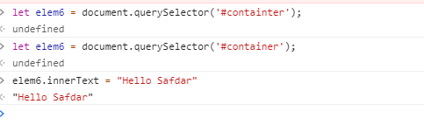

1. Add the class main to the div with a class of footer.

Solution:

Output:

1. Given the following HTML, create a script.js file to complete the first two parts.

Code:

<!DOCTYPE html>

<html lang="en">

<head>

 <meta charset="UTF-8">

 <title>DOM Exercise</title>

 <style>

 div {

 width: 50px;

 height: 50px;

 display: inline-block;

 }

 .brown{

 background-color: brown;

 }

 .green{

 background-color: green;

 }

 .blue{

 background-color: blue;

 }

 .purple{

 background-color: purple;

 }

 .yellow{

 background-color: yellow;

 }

 .car1 {

 background-color: #8C9C12;

 }

 .car2 {

 background-color: #1DA788;

 }

 .car1, .car2 {

 margin-left: 0;

 }

 </style>

</head>

<body>

 <h1 id="change_heading">Change Me!</h1>

 SELECTED COLOR <span class="selected">None!</span>

 <section>

 <div class="brown"></div>

 <div class="green"></div>

 <div class="blue"></div>

 <div class="yellow"></div>

 </section>

 <h2>Race!</h2>

 <button>Start the race!</button>

 <br>

 <div class="car1"></div>

 <br>

 <div class="car2"></div>

 <script src="task7.js"></script>

</body>

</html>

Script File

document.getElementById('change_heading').innerText = 'Dot_1 World';

function  hover_function(element)

{

    let text =  document.getElementsByClassName('selected')[0];

    text.innerText = element.getAttribute("class");

}

var square_box = document.createElement("DIV");

square_box.classList.add('purple');

document.getElementsByTagName('section')[0].append(square_box);

square_box.setAttribute('onmouseover','hover_function(this)')

Output:

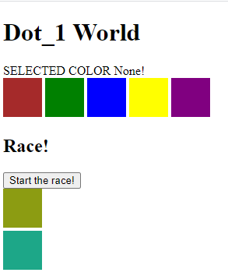

1. **For this task you will be combining your knowledge of DOM access and events to build a todo app!**

**As a user, you should be able to:**

**• Add a new todo (by submitting a form)**

**• Mark a todo as completed (cross out the text of the todo)**

**• Remove a todo**

**Now using localStorage, try to store your todos so that if you refresh the page you do not lose what you have added to the list! As a super bonus, try to also save todos that you have marked as complete**

**Output:**

